MEDITATION
A SILENT WEEKEND RETREAT
FRIDAY MAY 10th to SUNDAY MAY 12th 2019

PRESENTED BY THE BRISBANE THEOSOPHICAL SOCIETY AT THE
THEOSOPHICAL EDUCATION AND RETREAT CENTRE, 2184 SPRINGBROOK RD, SPRINGBROOK, QLD, 4213.

We invite you to join us in the tranquillity of this lovely bushland setting, for a weekend of meditation. Whether you are a beginner or a long-term practitioner, this retreat offers the opportunity to explore the mystery of what keeps us from the present moment, addressing impediments to transformation. This retreat will be run by Barry Bowden. Silence will be observed from bed time Friday evening until lunch time at 12.15 on Sunday except for discussion sessions. You will have a private room, and all meals are vegetarian. The cost is a total of $190 for TS members and $220 for non-members.

To REGISTER, please return a completed Registration Form (see below) and your payment. Payment Options:- By Post – send cheque and Registration Form to The President, Theosophical Society, 355 Wickham Terrace, Brisbane 4000. Cheques payable to: Brisbane Theosophical Society. By EFT – Account Details - Bank of Queensland, Account Name, Brisbane Theosophical Society, BSB # 124030, ACCOUNT # 10010157. Reference – “Retreat” followed by your surname. Please email receipt for payment and the Registration Form to brisbanelodge@theosophyqld.org.au In Person – by cheque, cash or EFTPOS during opening hours – Monday Tuesday Thursday Friday, 10.30am to 2.30pm, Wednesday 3.30pm to 7.25pm.
PLEASE NOTE: You must provide a completed form and payment (either deposit or full amount) to be registered. Closing date for registration: Wednesday 1st May. Deposit not refundable after 1/5/19.
We no longer have the kind service of Rod Bucknell. Specific enquiries about the meditation aspect of the weekend can be directed to the facilitator Barry Bowden on 0427 751 464 after 16th April. All other enquiries should be directed to Phillipa on 0449 887 609 or email phillipa@powerup.com.au
What to bring: Please bring your own single-bed linen, towel, etc. to help us minimise costs. You may also wish to bring a meditation cushion and blanket. A track suit (or similar), joggers, an umbrella, insect repellent and a torch could also be handy.
Note: Deposit not refundable after registration closing date. Balance payable by 6th May. Room allocation begins 4:30 pm Friday 10th May. Retreat ends after lunch on Sunday 12th May. Meals are vegetarian. Please advise Phillipa on 0449 887 609 by close of registration (Wed 1st May), if you need a late dinner or no dinner on Friday. The Centre is an alcohol & smoke-free zone.
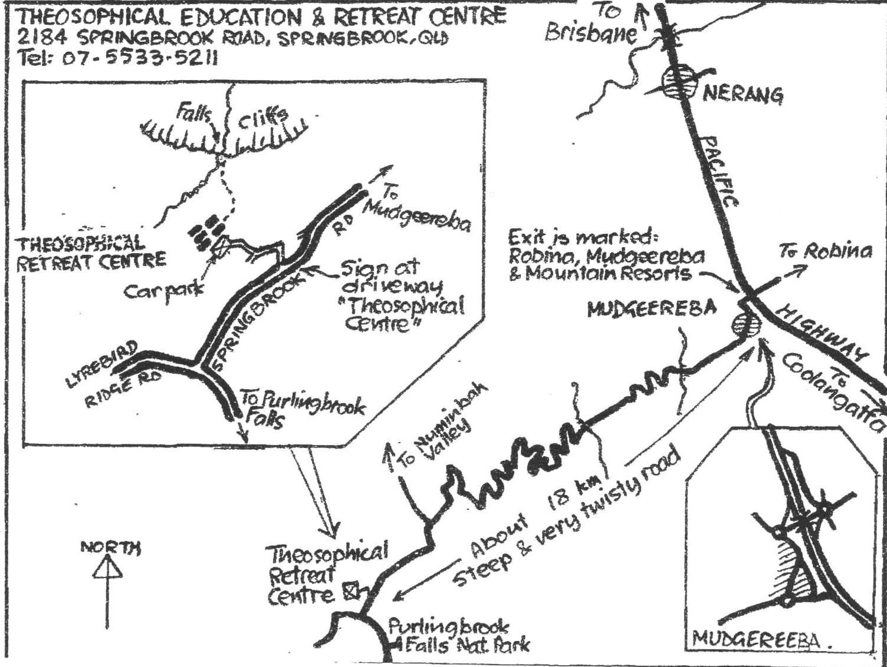
please detach ______________________________________________________________________
REGISTRATION FORM RETREAT MAY 2019
NAME .....................................................................................................................
ADDRESS ............................................................................... POSTCODE ………
PHONE................... MOBILE........................... E-MAIL............................................
EMERGENCY CONTACT (Name)…………………………. (Ph)……………… DO YOU NEED TRANSPORT TO SPRINGBROOK? YES ......... NO .......... WOULD YOU LIKE TO CAR SHARE? YES......... NO........... SPECIAL DIETARY NEEDS (e.g. vegan, gluten-free) ….........................................
IF ARRIVING AFTER 6 PM ON FRIDAY, PLEASE INDICATE APPROXIMATE TIME & WHETHER YOU WILL REQUIRE DINNER …………………………………...

I AM A TS MEMBER AND ENCLOSE DEPOSIT OF $90 OR FULL COST OF $190
or I AM NOT A TS MEMBER AND ENCLOSE DEPOSIT OF $90 OR FULL COST $220
(please cross out what does not apply and circle appropriate payment – thank you.)

SIGNATURE...................................................................... DATE ...........................

